**Documentation for**

**Conference Management System**

# Introduction

A conference management system is a software that aims to manage conference organization, handling tasks like abstract submission, scheduling, and attendee communication.

# Purpose

An SRS (Software Requirements Specification) for a conference management system outlines the system's functionalities, features, and other essential details. This document serves as a blueprint for developers, ensuring everyone involved is on the same page about what the system should do. This fosters clear communication, avoids misunderstandings, and ultimately leads to a system that effectively simplifies the entire conference process.

# Scope

The conference management system is designed to digitally orchestrate the entire conference experience. From attendee registration and fee collection to managing abstracts, reviewer assignments, and speaker logistics, it facilitates every stage, ensuring a smooth-running event.

# Definitions, Acronyms and Abbreviations

|  |  |  |
| --- | --- | --- |
| ACRONYMS | ABBREVIATION | DEFINITION |
| HTML | Hypertext Markup Language | Used to design static web pages |
| EJB | Enterprises java beans | a server-side component architecture for building Java applications that run  on a server |
| SQLite | Database | Delivers flexible and Cost effective database  Platform to build business  application. |

# Overview

The remainder of this document deals with the general requirements, in section 2, and the specific requirements, in section 3. Section 2 deals with requirements from the perspective of the end users of the product. It includes a few examples, requirements related to what the product must do for the user, and data that the user must send to and receive from the product. Section 3, on the other hand, deals with specific requirements and constraints of the project and it will

provide information about external hardware and skills a user must possess, various constraints on product based on users' needs, and the interconnectivity of our product with its surrounding environment and users.

# Overall Description

A conference management system acts as a central hub for both conference organizers and attendees. For organizers, it simplifies complex tasks like attendee registration, fee collection, and abstract/paper management with review tools. It streamlines speaker communication and logistics, and helps build the conference program.

Attendees benefit from a smooth registration process, easy access to the program and updates, and potentially tools for submitting proposals or interacting with other attendees. This all-in-one platform fosters clear communication and enhances the experience for everyone involved.

# Use-Case Model Survey

Conference management system operates like a digital maestro, conducting the conference symphony for both organizers and attendees. Organizers establish the A conference within the system, defining details and deadlines. Attendees register seamlessly online. The system then manages everything from abstract submissions and reviewer assignments to speaker communication and program building. After the event, reports and analytics help organizers improve future conferences. Attendees benefit from program access, potentially including recommendations and speaker bios, and some systems offer tools for interaction, enhancing the overall conference experience for everyone.

# Introduction

A use case is a methodology used in system analysis to identify, clarify and organize system requirements. A use case (or set of use cases) has these characteristics:

* Organizes functional requirements
* Models the goals of system/actor (user) interactions
* Records paths (called *scenarios*) from trigger events to goals
* Describes one main flow of events (also called a basic course of action), and possibly other ones, called *exceptional* flows of events (also called alternate courses of action)
* Is multi-level, so that one use case can use the functionality of another one.

# Survey Description Conference Setup

Organizers create a new conference profile within the system, defining key details like dates, deadlines, and other relevant information.

# Registration & Attendance Management

The system facilitates online registration forms with various payment options. Organizers can collect attendee information, manage communication through emails or announcements, and even generate badges for physical events.

# Abstract & Paper Management

The CMS allows authors to submit abstracts or papers electronically in designated formats. Organizers can assign reviewers, manage blind review processes (if applicable), and communicate with authors regarding their submissions.

# Scheduling & Program Building

Scheduling tools help allocate speakers to sessions, manage conflicts, and build the final conference program. This program can then be made accessible to attendees through the system.

# Speaker Management

Organizers can invite speakers, send emails with important details, manage travel logistics if needed, and receive speaker presentations through the system.

**Reporting & Analytics:** After the conference, the CMS allows organizers to generate reports on registration statistics, attendee demographics (optional), and feedback surveys. These reports provide valuable insights to improve future conferences.

# Use-Case Model Hierarchy Description:

The package allows users to login or register a user account - either as an Organizer or Attender in the system.

# Use Cases:

**Login-** The user has to login either as an attendee or as an organizer.

**Build Conference Program & Schedule-** Scheduling tools within the system empower organizers to allocate speakers to sessions, manage potential conflicts, and build the final conference program.

**Register for Conference-** Attendees can register for the conference through a user-friendly online form.

**Manage Registration & Attendance-** Organizers can design online registration forms, set up various payment options, collect attendee information, manage communication through emails or announcements, and even generate badges for physical events.

**Handle Abstracts & Papers-** The system should facilitate the submission of abstracts or papers electronically in designated formats by authors.

**Generate Reports & Analytics-** the CMS should allow organizers to generate reports on various aspects after a conference. These reports provide valuable insights to improve future conferences.

# Actors:

**Organizer-**They are responsible for planning and managing the conference. They utilize the system to set up the conference profile, manage registration and attendance, handle abstracts and papers, build the program and schedule, manage speakers, and generate reports and analytics.

**Attendee-** They are the individuals who participate in the conference. They use the system to register for the conference, access the program and schedule, and potentially interact with other attendees

**Reviewer-** Reviews the papers which are submitted by the attendee

# Database manager:

The database manager maintains the Organizer and the Attendee information.

# Diagrams of the use case model

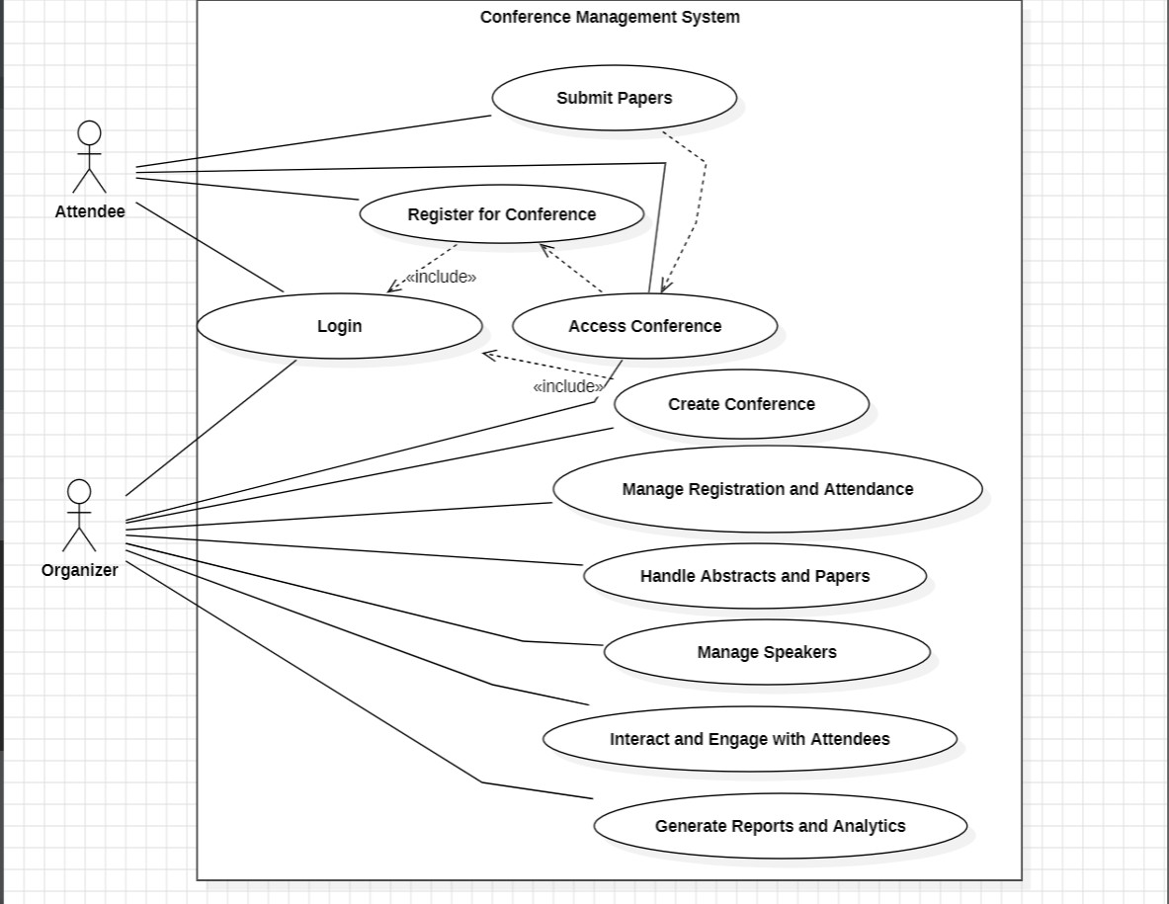

# Assumptions and Dependencies

* The system should be designed with user-friendliness and accessibility.
* Roles and responsibilities are already established.
* Robust security measures and data encryption is needed.

# Requirements

It is possible in the future that a few additional features be implemented into this system.

* **Management system:** This will allow the system to manage effectively the other resources in the easiest way.
* **Integration with AI:** This will allow the attendees to generate notes and summary and for Organizers automated scheduling and speaker management

# Use-Case Specifications

The use case for Conference Management system is register for conferences or symposiums, present papers and abstracts, maintain them and analysis of feedbacks on how to improve the management.

# Functionality

A conference management system (CMS) functions by processing user inputs to generate desired outputs that streamline conference management tasks

# Inputs:

Organizers provide the initial groundwork by entering conference details, user information (including speaker profiles), and program specifics like session schedules and speaker assignments. They might also upload abstracts or papers for review (if applicable) and craft communication materials like emails and announcements. Attendees contribute their registration information, including personal details and preferred sessions, and potentially offer feedback through surveys after the conference.

# Processing:

The system securely stores all data – conference details, attendee information, program schedules, and registration choices – in its database. User accounts are managed, assigning different access levels for organizers, speakers, and attendees. For conferences with paper submissions, the system facilitates the review process, potentially including reviewer assignments, anonymized review functionalities, and score allocation. Program details are used to build the conference schedule, manage session timings, and assign speakers to presentation slots. Registration data is processed to confirm attendee participation, handle online payments (if applicable), and generate registration confirmations. Finally, communication management for allowing organizers to send emails, manage an announcement board, and potentially integrate with mobile app notifications.

# Outputs:

Its outputs are

* Dashboard for managing conference details, data, schedules for organizers.
* Reports on attendees, participation, feedback for organizers.
* Communication tools (emails, announcements) for organizers.

# Performance

Conference Management system should provide a good performance as the whole process of registration, accessing the conference takes place within few seconds and the management also secured.

# Response Time

In case of accessing a conference, the user logs in to the registered conference. He/She can access it in a few minutes without any lags.

# Capacity

Any number of attendees at a time for a conference.

# Interfaces

**User Interfaces:**

Its interface differs to both organizers and attendees. Organizers benefit from a central dashboard with easy navigation for managing registrations, programs, and communication. Customization options and insightful reports empower informed decisions. Attendees enjoy a smooth registration process, easy program access (potentially with recommendations and speaker bios), and optional features like attendee interaction or mobile app convenience.

# Hardware Interfaces:

Hardware interface will be keyboard, mouse, monitor.

# Software Interfaces:

All data handling is done by DBMS so we require SQL along with windows. Conference Management System Software, Operating System. Depending on specific functionalities, the system might utilize additional software like:

* Payment processing gateway (for online registration fees)
* Email server (for sending system-generated emails)
* Video conferencing software (for integrating virtual presentations)

# Communication Interface:

* Client on Internet will be using HTTP/HTTPS Protocol.
* Client on intranet will be using TCP/IP protocol

# Licensing Requirements

The license should be obtained from cite ware which allows the modification of the source code at any time.

# Legal, Copyright and Other Notices

NONE

# Applicable Standards

NONE